Daniel‌ ‌Savin‌ ‌-‌ ‌40010051‌ ‌

Karl‌ ‌Noory‌ ‌-‌ ‌40059592‌ ‌

Thomas‌ ‌Tran‌ ‌-‌ ‌4009564‌ ‌

Vicentiu-Cristian‌ ‌Badea‌ ‌-‌ ‌40027683‌ ‌

Jun‌ ‌Young‌ ‌Kim‌ ‌-‌ ‌40063176‌

**Milestone 2**

# 1. Information on stakeholders

We have performed a total of 7 interviews, following the above script: 4 of the participants self-identified as female 3 as a male. The average age of participants is 30.9 years with the median of 24 years. No correlation was observed between the age, gender, and the amount of plants owned.

Stakeholder 1, potential customer: Inessa, female, 49 years old. Nurse, living in a suburban area of Laval. Main interests include reading, cooking, and connecting with nature. Owns 6 plants for emotional reasons and thinks that they give good moods and promote a healthy atmosphere at home. Has inconsistent plant care routine, however that does not translate to plant loss.

Stakeholder 2, potential customer: Natali, female, 22 years old. Accounting student living in Montreal. Owns 19 plants for aesthetic and emotional reasons. Main interests include cooking, music (dancing and listening) and hiking. Owns 19 plants, from which 2 are preserved and 2 are bouquets. Takes care about plants consistently, generally has no problems with plants.

# 2. Interview script

Interview script was designed to cater mostly to people who own plants. The following questions were asked one after another, to obtain the resulting answers.

1. Small talk.
   1. How is the weather?
   2. What have you been doing during quarantine?
2. Establishing the user profile (I).
   1. How old are you?
   2. What gender do you identify as?
   3. What is your current occupation?
   4. What are your three main interests?
   5. What type of phone do you have?
   6. How many plants do you own (real or fake)?
   7. What is your relationship with plants: emotional or material?
   8. Do plants affect your emotional state? If yes, how?
3. Assessing the problem (IIA).
   1. Give me a situation where you had problems with your plants.
   2. What is most frustrating about owning a plant?
   3. Have you ever had trouble keeping your houseplants healthy?
   4. Do houseplants die on you often? Why?
4. Understanding the environment (IIB).
   1. Where are your plants situated?
   2. How much free time do you have daily to take care of your plants?
   3. What is your plant care routine(s)?
   4. What tools do you use to help yourself take care of your plants?
5. At this point, the information is recapped by reassessing user demographic, amount of plants, problems, and emotional connection (IIC).
6. Analyst's inputs on the customer problem: It is hard to keep our houseplants healthy because we do not have exact data, is this a problem you relate to (III)?
7. Then, the general idea of the project is described: “We aim to make a sensor system that will allow to track soil moisture, light exposure and ambient temperature. Based on that data, notifications will be sent to the user” (IV).
8. Assessing the opportunity (V).
   1. What kind of features would you like to see in the solution?
   2. What price would you pay for a product that has these features?
9. Assessing the reliability, performance, and support needs (VI).
   1. How exact and precise would you want your information to be?
   2. How often would you like to be updated with information?
10. Other requirements (VII).
    1. Do you see any environmental or legal issues that may arise from using our solution?
11. Wrap-up (VIII).
    1. Any other questions I should be asking you?
    2. May I give you a call if I have follow-up questions?
    3. Thank the interviewee.
12. The analyst’s summary (IX).

# 3. Interview Outcomes

Interview answers were written down as precisely as possible so each member of the team could give the outcomes that were taken out of each interview without setting the interviewee. The outcome table for each teammate and each interview can be found in 9.2 Interview Outcomes. Based on outcomes, the following conclusions were drawn.

1. Hardware:
   1. Some plants are grown outside, thus the product should be somewhat rugged.
2. Software:
   1. Data is not relevant for most users; notifications are more important.
   2. There should be an option for choosing the frequency of notifications.
   3. Some users have iPhone.
3. User experience:
   1. Majority of users have an emotional attachment to their plant.
   2. Proper watering (amount and schedule) is the biggest concern.
   3. If a plant gets sick, users are not sure what is wrong.
4. Production/marketing:
   1. The more plants a user has, the less they are ready to pay. While users with <10 plants are ready to pay from 20$ to 40$, users with more plants are ready to pay up to 10$ for a device. This is of concern since the preliminary study of market and hardware shows that a Wi-Fi/Bluetooth module itself is 10$.

The points 2a, 3b, and 4a are deemed most important for our team since we are aiming to make a product for indoor plants and Android users primarily. Finally, a plant “doctor” device is an interesting idea, but there are many variables that are either impossible to measure within the scope of the project (time) or are too expensive to integrate (money, refer to point 4a). Without those variables, the data would not be conclusive (ex.: Interview 7: Japanese Beetle was eating leaves; measuring soil moisture would be useless in this case and having motion sensors for insects is an overkill).

# 4. Product Backlog

In order to provide a clear visual representation of the product backlog, the initiative, epics, user stories and tasks have been compiled into a graphical representation, which will be broken down into several components below to contain its clarity.

The legend shown below will serve to distinguish the following rectangular shapes into the components mentioned above.

The initiative, as stated, is developing “an application that will allow users to monitor the moisture, temperature and light exposure of house plants for the general market. The initiative has been split into two epics:

1. Phone wireless connected interface GUI
2. Plant environment measuring system

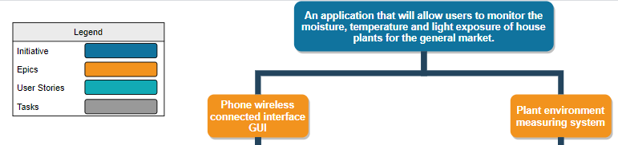

Following the epics, we have specific user stories for each one and their related tasks.

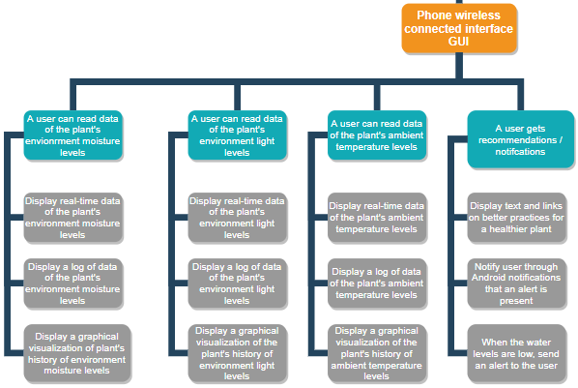

The main purpose of the Phone wireless connected interface GUI will be to display the read data from the product onto the user's phone. According to the different sensors used on the hardware, the tasks have been split into their respective User Story containers. The phone application should also notify or recommend solutions to the user based on the acquired data.

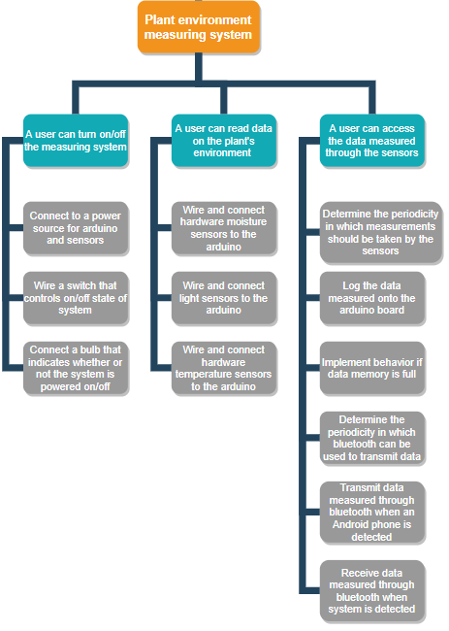

The plant environment measuring system has been split into the requirements of the hardware components of the product, giving the user the ability to turn on/off the measuring system, read the plants data and access the data measured. The above is further split into their relevant tasks.

The diagram above represents our initial idea for our product, after several brainstorming and design meetings. In fact, this initial planned product backlog was designed before conducting the interviews with our potential users. After acquiring additional information from consulting our stakeholders, we have restructured the product backlog to contain the inputs of the interviewees. This new revised and weighted product backlog can be shown below. The revised plan represents our system and how we will achieve sprint 1, together with the relevant user stories and respective tasks. Product backlog can be found in 9.3 Product Backlog (clickable), at the end of the document.

# 5. Computer simulation plan

The goal of our computer simulation is to learn more about plants behaviors and growth reactions to the surrounding environment. From the simulation, we hope to see how trends over time can help plant care takers optimize for goal (plant growth, food production, oxygen production, etc.…). The main aspects of the simulation should be plant profile simulations, environment simulation and finally hardware simulation. The results should show us how change in the environment helps or hinder plant processes like photosynthesis for example. All the data collected from the virtual hardware should be represented in graphs that are comprehensive for end users. The collection of the data over time can help us discover new facts about certain plants that have previously never been noticed by plant owners.

The simulation should be designed with a programming language that is data focused like Python or MATLAB since we will be dealing with multiple changing variables. Additionally, we have the option of simulating the physical hardware with platforms like UnoArduSim which would allow us to play around with certain configurations to find the optimal solution without risking any budgetary losses.

# 6. Ethical Dimensions

Many mobile applications have inherent ethical pitfalls such as collecting too much information (i.e. application having access to more than necessary user information like contacts and location), misdirecting ads that either hinder the use of the application itself (ex: pop-ups, unskippable ads in the middle of application use, etc.) or are by nature advertising something unethical, trivial microtransactions, and vaguely phrased questions to trick users into giving positive answers (ex: prompting users to fill out surveys filled with questions of biased connotation).

Furthermore, given the wireless nature of Wi-Fi connection, this can potentially lead to a breach in security.

For the hardware side of the project, there is the concern over the longevity of the product and its potential environmental effect. If many units are sold but the product itself has a short shelf life, this may lead to a negative ecological footprint. The product will contain a plastic casing, three sensors and a battery. The disposal of these items should be studied and recycled where possible.

As for the app development process, when using code or software not designed by team members, proper credit must be given and never stolen.

Finally, as app developers, we must be completely transparent with the user base and have a clear privacy policy which dictates what exactly is done with the information the application records.

# 7. Team blog

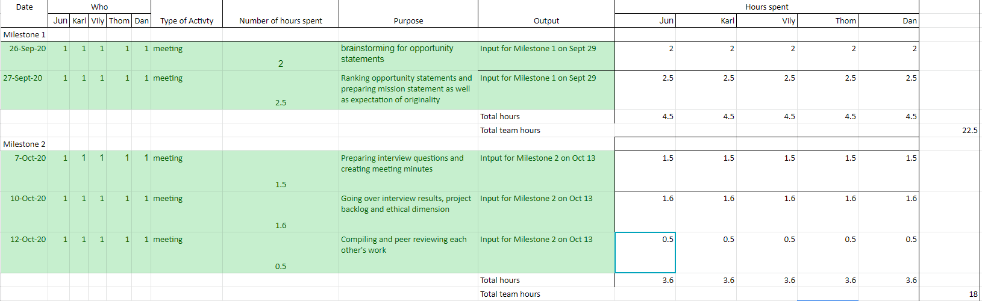

# 8. Expectation of originality form

**Faculty of Engineering and Computer Science**

**Expectations of Originality**

This form sets out the requirements for originality for work submitted by students in the Faculty of Engineering and Computer Science. Submissions such as assignments, lab reports, project reports, computer programs and take -home exams must conform to the requirements stated on this form and to the Academic Code of Conduct. The course outline may stipulate additional requirements for the course.

1. Your submissions must be your own original work. Group submissions must be the original work of the students in the group.

2. Direct quotations must not exceed 5% of the content of a report, must be enclosed in quotation marks, and must be attributed to the source by a numerical reference citation. Note that engineering reports rarely contain direct quotations.

3. Material paraphrased or taken from a source must be attributed to the source by a numerical reference citation.

4. Text that is inserted from a web site must be enclosed in quotation marks and attributed to the web site by numerical reference citation.

5. Drawings, diagrams, photos, maps or other visual material taken from a source must be attributed to that source by a numerical reference citation.

6. No part of any assignment, lab report or project report submitted for this course can be submitted for any other course.

7. In preparing your submissions, the work of other past or present students cannot be consulted, used, copied, paraphrased or relied upon in any manner whatsoever.

8. Your submissions must consist entirely of your own or your group’s ideas, observations, calculations, information and conclusions, except for statements attributed to sources by numerical citation.

9. Your submissions cannot be edited or revised by any other student.

10. For lab reports, the data must be obtained from your own or your lab group’s experimental work.

11. For software, the code must be composed by you or by the group submitting the work, except for code that is attributed to its sources by numerical reference.

**“We certify that this submission is the original work of members of the group and meets** **the Faculty's Expectations of Originality”.**

We certify that we have read the requirements set out on this form, and that we are aware of these requirements. We certify that all the work we will submit for this course will comply with these requirements and with additional requirements stated in the course outline.

Course number: ELEC/COEN 390

Instructor: Dr. Wahab Hamou-Lhadj

Date: October 13th, 2020

Daniel Savin - 40010051



Jun Young Kim - 40063176



Karl Noory - 40059592



Thomas Tran - 40095654



Vicentiu-Cristian Badea - 40027683



# 9.0 Appendix

## 9.1 Interviews

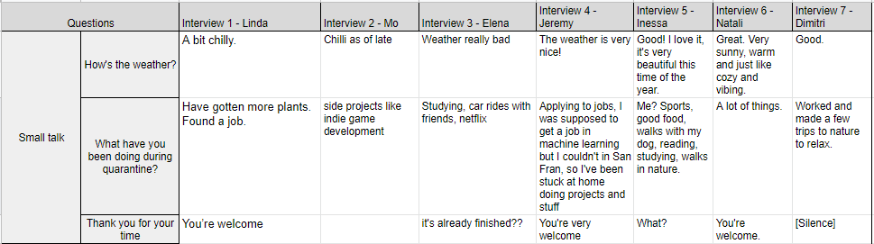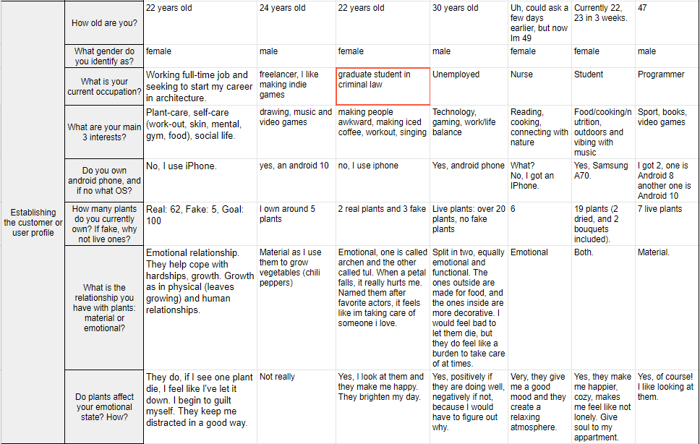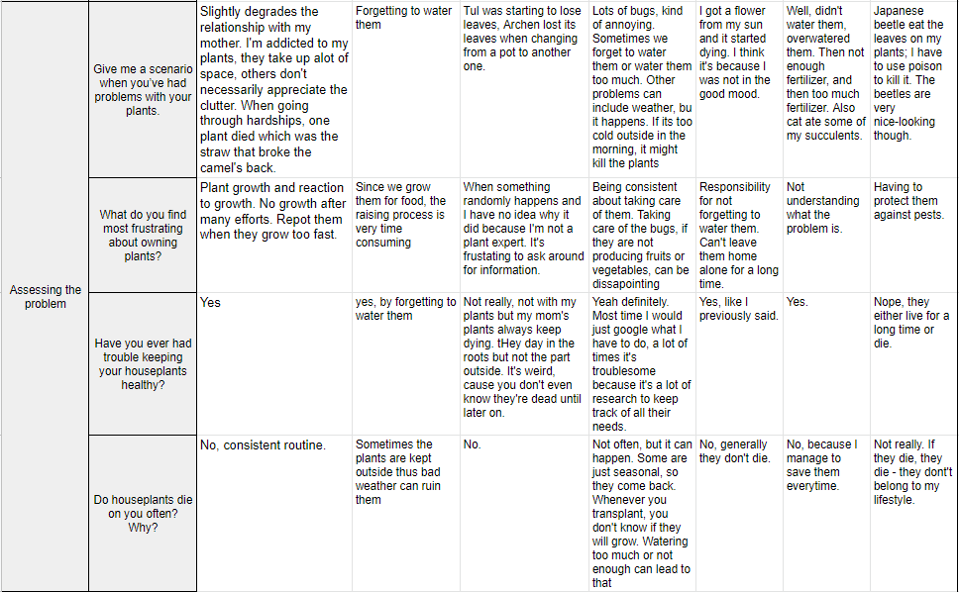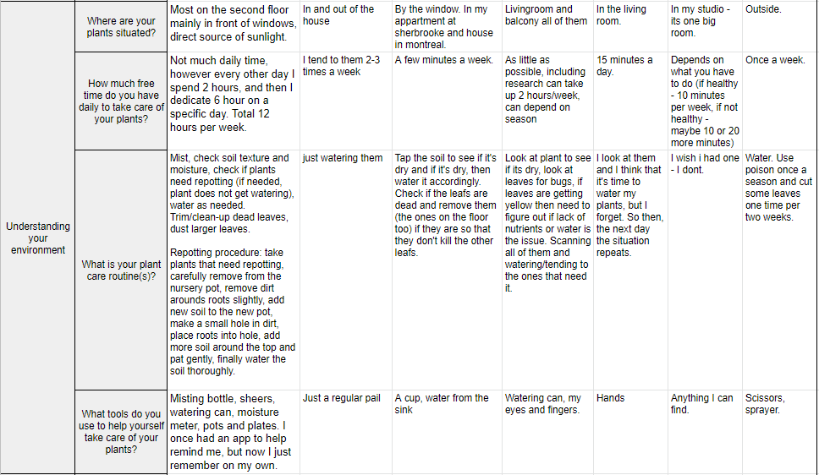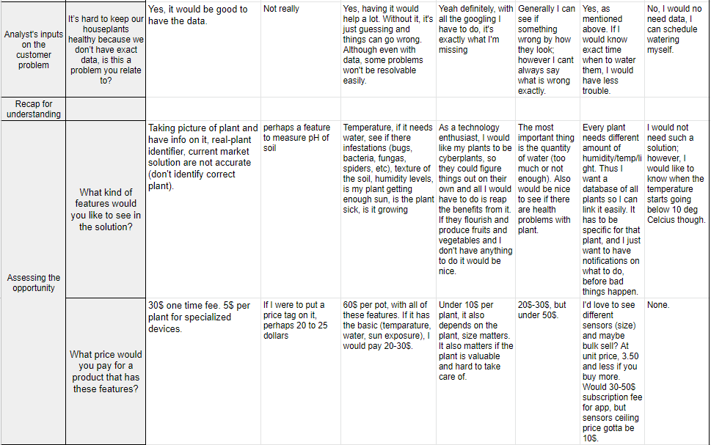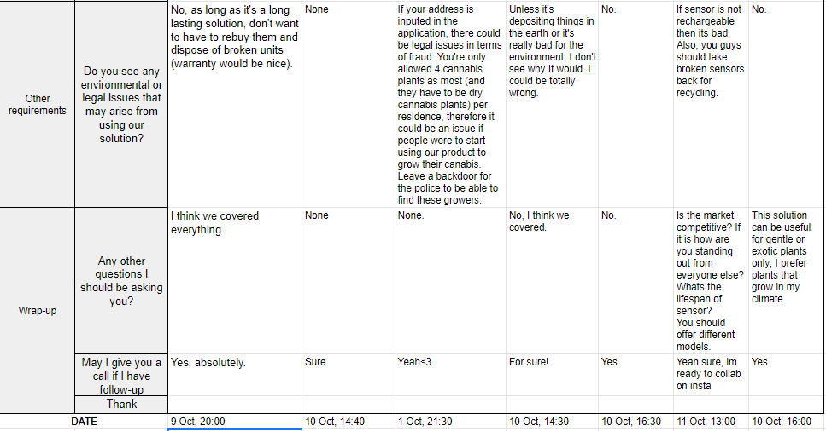

## 9.2 Interview Outcomes

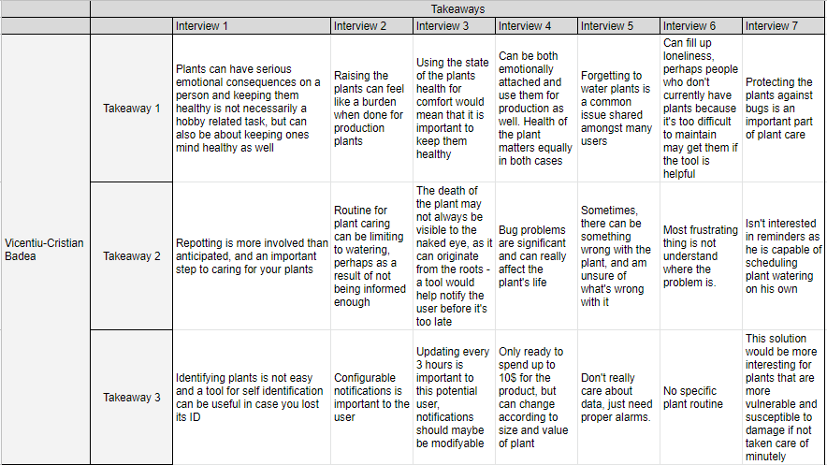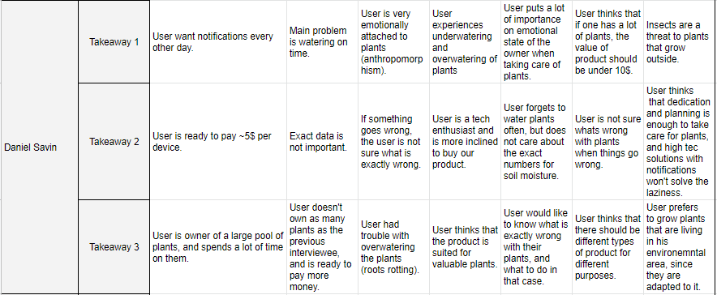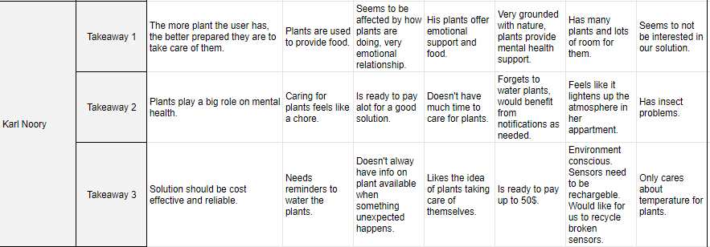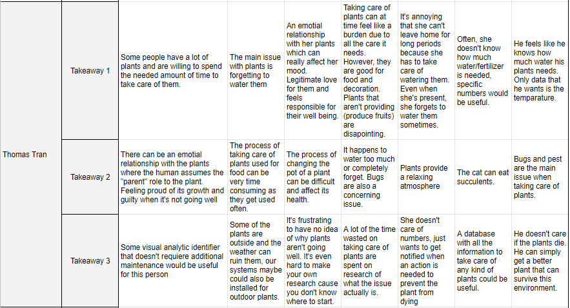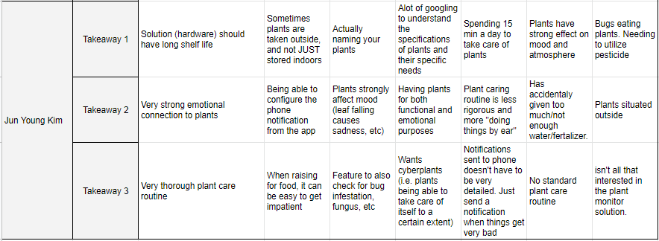

## 9.3 Team Minutes

**Team Meeting**

**07 October 2020** / 19:00 / Discord Server

**Attendees**

Daniel, Thomas, Jun, Karl, Vily

**Agenda**

1. Define milestone 2.
2. Prepare the interview script.
3. Find who to interview.
4. Get date/time for next meeting.

**Notes**

* Keep your interview questions open-ended, so the person answering would not be socially pressured to answer you.
* At least ten interviews (2/teammate).
* Project: app does notifications when moisture levels are too low and when there is not enough sunlight. Also, give fertilizer/repotting notification.

**Action Items**

1. [ALL] Interview at least 2 persons.
2. [Daniel] Complete Team Blog (meeting duration = 1.5 hrs).

**Next Meeting Agenda**

Next meeting: 10 October 2020, 09:30, Discord.

1. Collect and analyze interview results.
2. Product Backlog.
3. Computer Simulation.
4. Ethical dimensions.

**Team Meeting**

**10 October 2020** / 09:30 / Discord Server

**Attendees**

Daniel, Thomas, Jun, Karl, Vily

**Agenda**

1. Collect and analyze interview results.
2. Product Backlog.
3. Computer Simulation.
4. Ethical dimensions.

**Notes**

* Epics > stories.
* Bluetooth or WiFi?
* Meeting with Bipin scheduled for Oct 20, 11:00 (Zoom).

**Action Items**

1. [ALL] Produce an ethical dimensions document based on AI 1.
2. [Daniel] Schedule Sprint 1 with Bipin.
3. [Daniel] Finish blog.
4. [Thomas] Stories.
5. [Karl, Vily] Write on how-to simulate stuff.
6. [Jun] Ethical Dimensions.
7. [Daniel] Analyze interviews.

**Next Meeting Agenda**

Next meeting: 11 October 2020, 19:30-20:30, Discord.

1. Go over all the points.
2. Polish the Milestone 2.
3. Submit the Milestone 2 (Due Oct 13).

**Team Meeting**

**12 October 2020** / 20:00 / Discord Server

**Attendees**

Daniel, Thomas, Jun, Karl, Vily

**Agenda**

1. Go over all the points.
2. Polish the Milestone 2.
3. Submit the Milestone 2 (Due Oct 13).

**Notes**

* Integrate one sensor (moisture) properly, and then do other sensors.
* Due to interview outcome and the price of Bluetooth, look into the possibility of either:
  + Making cheaper sensors.
  + Making a more specialized tool.

**Action Items**

1. [ALL] Polish product backlog.
2. [ALL] Make interview outcomes.
3. [ALL] Polish document and submit it.

**Next Meeting Agenda**

Next meeting: TBD on FB chat.

## 9.3 Product Backlog

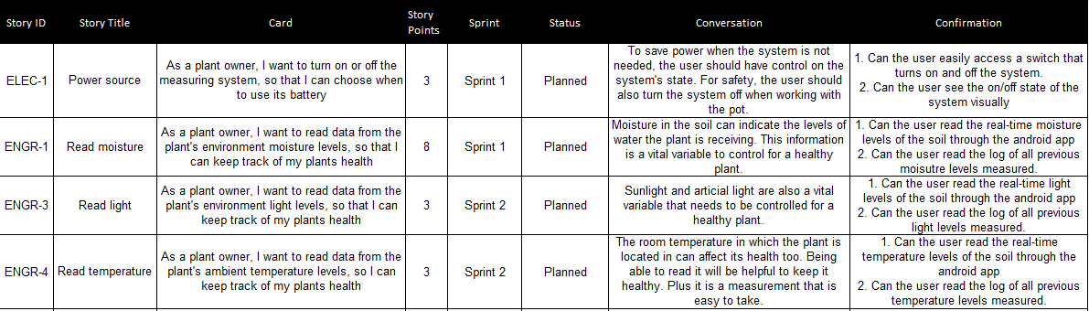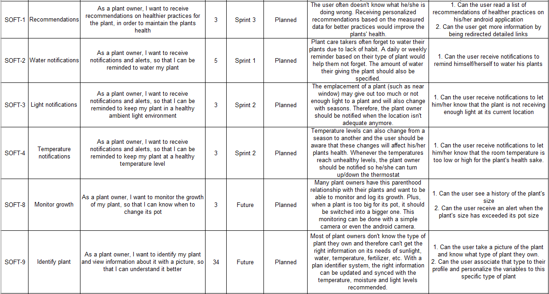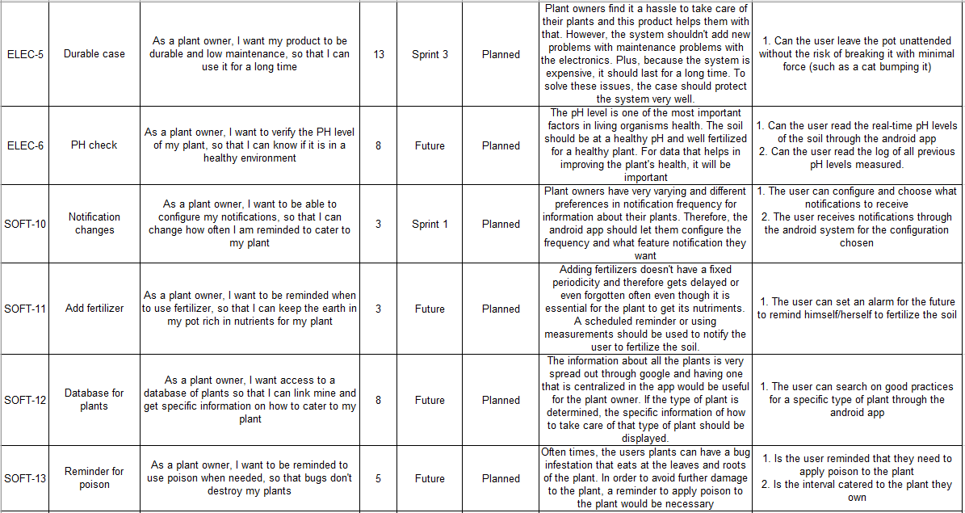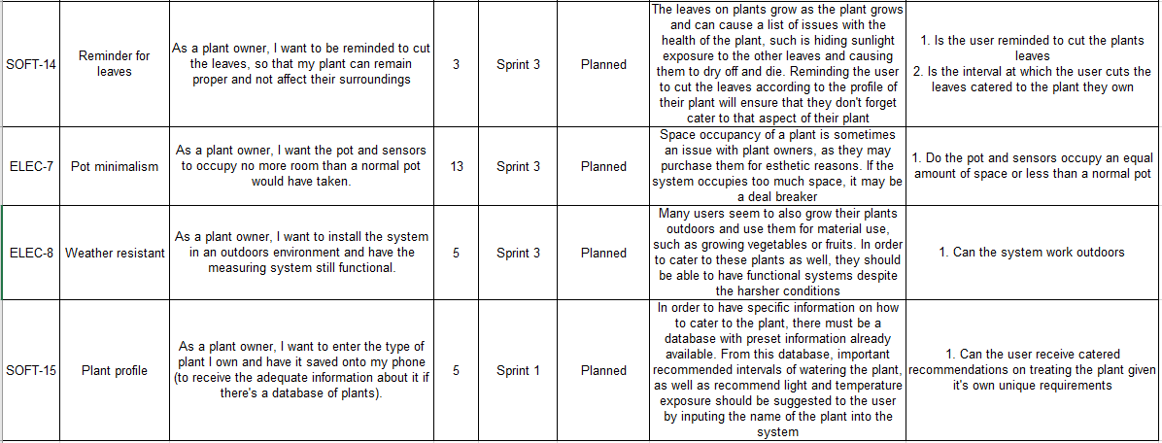

## 9.4 Sprint 1

